Bradley Lowe
Chelsea Thompto
ART 2434
25 September 2026

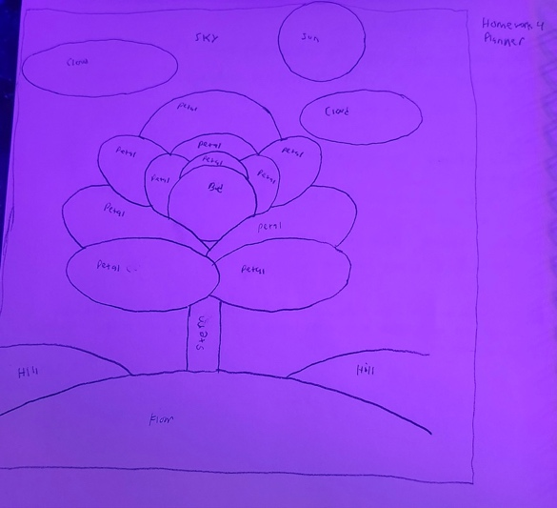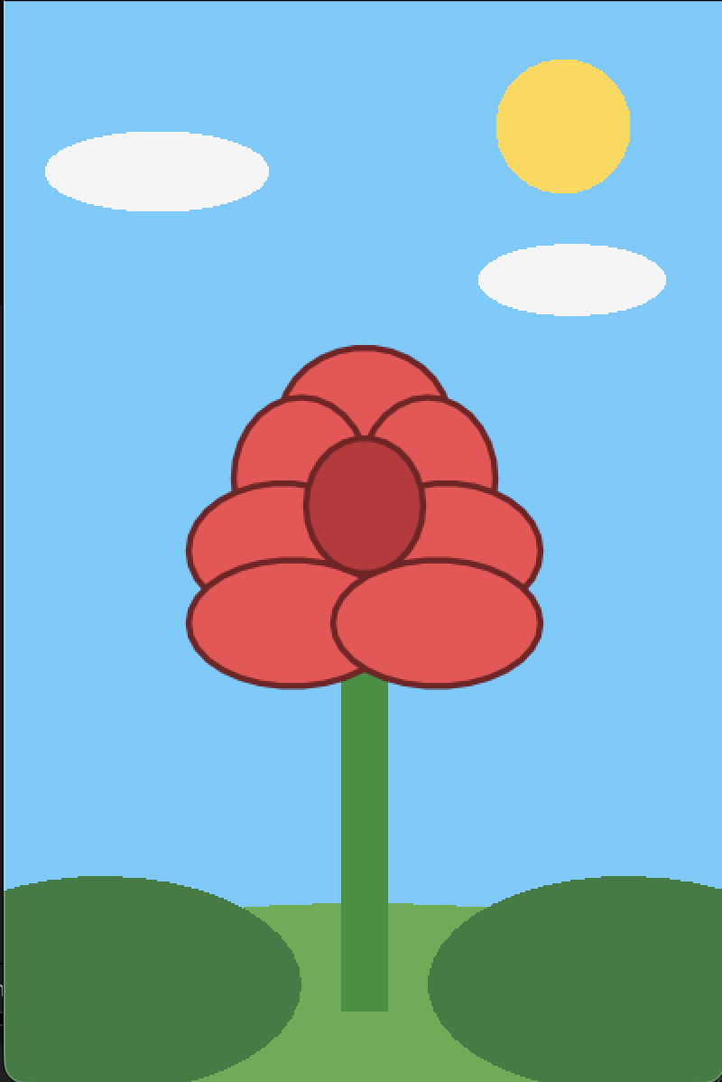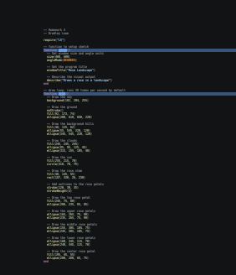

Code:
-- Homework 4
-- Bradley Lowe

require("L5")

-- function to setup sketch
function setup()
-- Set window size and angle units
size(400, 600)
angleMode(DEGREES)

-- Set the program title
windowTitle("Rose Landscape")

-- Describe the visual output
describe("Draws a rose in a landscape")
end

-- draw loop, runs 30 times per second by default
function draw()
-- Draw the sky
background(102, 204, 255)

-- Draw the ground
noStroke()
fill(92, 173, 74)
ellipse(200, 610, 650, 220)

-- Draw the background hills
fill(48, 125, 62)
ellipse(55, 545, 220, 120)
ellipse(345, 545, 220, 120)

-- Draw the clouds
fill(245, 245, 245)
ellipse(85, 95, 125, 45)
ellipse(315, 155, 105, 40)

-- Draw the sun
fill(255, 215, 70)
circle(310, 70, 75)

-- Draw the rose stem
fill(40, 145, 55)
rect(187, 330, 26, 230)

-- Add outlines to the rose petals
stroke(120, 30, 35)
strokeWeight(3)

-- Draw the top rose petal
fill(245, 75, 80)
ellipse(200, 235, 95, 85)

-- Draw the upper rose petals
ellipse(165, 265, 75, 90)
ellipse(235, 265, 75, 90)

-- Draw the middle rose petals
ellipse(155, 305, 105, 75)
ellipse(245, 305, 105, 75)

-- Draw the lower rose petals
ellipse(160, 345, 115, 70)
ellipse(240, 345, 115, 70)

-- Draw the center rose petal
fill(195, 45, 55)
ellipse(200, 280, 65, 75)
end

